1.

2.

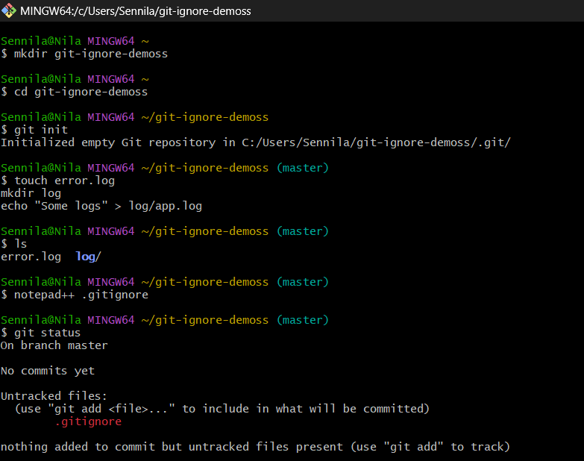

4.

5.

